Solar Radiation Pattern Analysis in Sri Lanka using Fuzzy C-Mean Clustering

H.M.N.B.Herath
HNDDS242F-009
Higher National Diploma in Data Science
National Institute of Business Management (NIBM)
Colombo, Sri Lanka
2026.01.12

A Project Proposal submitted for the partial fulfillment of the requirements of the higher National Diploma in Data Science Programme

Acknowledgement
I sincerely thank my supervisors, Sir Ashan and Ms. Donpaul, for their invaluable guidance and valuable feedback throughout this research. Their suggestions greatly contributed to the successful completion of this study.

Abstract

Solar radiation plays a critical role in solar energy production is very important but due to changing weather and environmental conditions its behavior has been found to change tremendously. These fluctuations complicate and render the solar radiation data complicated and cannot be analyzed through simple methods of analysis. This paper seeks to identify the solar radiation patterns on various days in Kirulapone, Sri Lanka, using an unsupervised learning method which is the Fuzzy C-Means (FCM) clustering.
The analysis uses the hourly solar radiation and environmental data of the year 2019 retrieved through NASA MERRA-2 dataset which is based on satellites. The important variables are Direct Normal Irradiance (DNI), Diffuse Horizontal Irradiance (DHI), temperature and electricity production. DNI was used to determine Global Horizontal Irradiance (GHI) which was combined with DHI and Solar Zenith Angle (SZA). Moreover, derived measures like the Direct -Diffuse ratio (DDR), Coefficient of Variance of GHI (CVGHI) and Coefficient of Variance of Irradiance (CVDNI) were also calculated to facilitate the pattern recognition. Daily data were summarized to hourly data and normalized using the min max scale before clustering.
Fuzzy C-Means was used to determine groupings of data that are natural. The best number of clusters was estimated with the help of Partition Coefficient (PC) and XieBeni Index (XB) both of which showed that the two clusters are the most appropriate clustering structure. These findings showed two different patterns of the solar radiations of clear-sky days dominated by direct radiations and cloudy days dominated by diffuse radiations. Independent samples t-test established that there is a statistically significant difference between the means of GPI in the two clusters.
The results prove that the Fuzzy C-Means clustering is a powerful tool in the process of identifying meaningful patterns of solar radiation and offers valuable information on the analysis of solar energy in tropical areas like Sri Lanka.

Table of Contents
Chapter 1: Introduction
1.1 Background
1.2 Research Problem
1.3 Research Questions
1.4 Objectives of the Project
1.5 Scope of the research
1.6 Justification of the Research
1.7 Expected Limitations
1.8 Proposed work schedule
Chapter 2: Literature Review
2.1 Introduction to the research theme
2.2 Theoretical explanation about the Key Words in the Topic
2.3 Findings by other researchers
2.4 The research gap
2.5 Table for Variables, their definitions and sources
2.6 Chapter conclusion
Chapter 3: Methodology
3.1 Introduction
3.2 Population, sample and Sampling technique
3.3 Type of Data to be collected and data sources
3.4 Data collection tools and plan
3.5 Conceptual framework
3.6 Hypothesis
3.7 Operationalization Table
3.8 Methods of data analysis
Chapter 4: Data Analysis
4.1 Data Analysis
4.2 Findings and Interpretation
Chapter 5: Discussion and Recommendations
5.1 Discussion
5.2 Recommendations
5.3 Conclusions

List of References

Chapter 1: Introduction

  - Background
Solar energy is a significant source of renewable energy, and its performance largely relies on the availability of solar radiation. Solar radiation varies according to weather conditions, temperature and cloud cover throughout the day. Due to these variations solar radiation data is very dynamic and occasionally uncertain and therefore not easily analyzed using simple or traditional means.
The study of such intricate data is often done through the application of pattern recognition methods. One of the methods that can be used is the clustering which is used to cluster similar points of data without using any prior data labels. In the traditional clustering algorithms such as the K-Means, a set of data points are allocated to a single cluster. This method is, however, not effective when the data points have overlapping characteristics as is the case with data on weather and solar radiation.
Fuzzy C-Means (FCM) clustering will be better in this kind of data since it can permit a data point to be a member of multiple clusters having varying membership values. This assists in the better depiction of the uncertainty and slow variations in solar radiation patterns. Fuzzy C –Means clustering is applied to solar radiation and environmental data collected from kirulapone, Sri Lanka, to identify distinct solar radiation patterns. And their relationship with electricity and climate variability.

  - Research Problem
Solar radiation data changes due to weather and environmental conditions, so the data shows uncertainty and overlapping patterns. Most studies use traditional clustering that assigns data points to one group, but it does not properly represent these variations. this study addressed absence of effective fuzzy pattern recognition framework for identifying and interpreting solar radiation regimes in Sri Lanka.

  - Research Questions
How Fuzzy C-Means clustering effectively identify solar radiation patterns based on irradiance, temperature, variability and electricity indicators.
How to validate identified solar radiation patterns by evaluating fuzzy cluster quality and statistically testing differences in Global Horizontal Irradiance (GHI)?

  - Objectives of the Project
To identify and characterize solar radiation patterns using Fuzzy C-Means clustering based on irradiance, temperature, variability and electricity indicators.
To validate identified solar radiation patterns by evaluating fuzzy cluster quality and statistically testing differences in Global Horizontal Irradiance (GHI)

  - Scope of the research
This study aims the pattern recognition in solar radiation in Kirulapone, Sri Lanka using NASA MERRA-Satellite data in 2019. This is limited to one year data that is aggregated to daily features. The study considers key variables including direct irradiance , diffuse irradiance, global horizontal irradiance , temperature , direct – diffuse ratio , variability and electricity.

  - Justification of the Research
This study is substantiated both methodologically and practically. Methodologically, the use of Fuzzy C-Means clustering is more realistic as far as modeling solar radiation patterns is concerned since it explicitly considers the uncertainty and the smoothness of transition between the atmospheric conditions. Fuzzy validity indices are used including Fuzzy Partition Coefficient (FPC) and the XieBeni index, which enhances the strength and validity of the achieved clustering results.
In a practical sense, the knowledge of the daily patterns of solar radiation is useful in the planning of solar energy, measurement of system performance, and decision-making in a problematic environment. The results of this study could be helpful in guiding energy analysts and researchers to advance the characterization of solar resources in tropical areas like Sri Lanka.

  - Expected Limitations
This analysis is based on data from single geographical location, that limit generalizability of the findings to other regions. The aggregation of hourly data into daily indicators may result in the loss of short term variability information. The study relies on unsupervised clustering so the interpretation of clusters depends on knowledge of domain and not the truth that is externally labeled.

  - Proposed work schedule

Research step | Duration
Topic selection | 4th week of July 2025
Data set approval | 1st week of August 2025
Study research papers | August 1st week – August 3rd week 2025
Proposal submission | August 19th 2025
Final Viva | January 12th 2026

Chapter 2: Literature Review

2.1 Introduction to the research theme
Pattern recognition is an data analysis that focuses on finding regularities pattens in large and complex datasets. It is used in many fields like image processing , weather analysis etc.., In this study pattern recognition helps to understand how solar radiation behaves under different environmental conditions. Solar radiation does not remain constant throughout the day so it changes continuously due to cloud cover , temperature etc. because of these variations the solar radiation data often show uncertain and overlapping behaviors. Identifying patterns in such data is difficult.
Pattern recognition methods are used to analyze solar radiation data based on their similarities. Among these clustering is very important unsupervised learning techniques that can group similar data points without needing labels. traditional clustering methods like k means assign each data points to a one cluster but it’s not suitable for the data that have overlapping and difference between patterns like solar radiation data.
To address this Fuzzy C- means clustering is used. this allows datapoints to belong to more than one cluster with different degrees of membership. So pattern recognition using fuzzy clustering provides a realistic way to study solar radiation behavior specially in kirulapone, Sri Lanka, identifying solar patterns makes it easy for improve solar energy and evaluate system performance and understanding the relationship between solar radiation and environmental factors.

2.2 Theoretical explanation about the Key Words in the Topic
Solar Radiation: Solar energy emitted by the sun onto the Earth expressed as W/m2 and the major input to the solar energy facilities and prediction research.
Pattern Analysis: it is a process that is used to understand meaningful relationships, similarities in data
Fuzzy C-Mean Clustering: it an advance unsupervised clustering algorithm, that each data point can belong to more than one cluster.

2.3 Findings by other researchers
The model provided in this paper is an integrated forecasting model incorporating Fuzzy C-Means (FCM) clustering, XieBeni (XB) index, and a Backpropagation (BP) neural network to increase the accuracy of forecasting, especially when using sales data with poor trend or seasonality. The XB index is also used to determine the optimum number of clusters objectively because FCM performance is very sensitive to the specified number of clusters and the XB index is used to check the compactness and separation of clusters. The suggested methodology has three primary steps: data normalization by min–max method, normalized data clustering by FCM with various clusters and choosing the best number of cluster that is determined as three. The data is then optimally clustered as inputs into individual BP neural networks and generates more homogenous data which are easier to learn the underlying patterns with. The findings of the experimental work on the basis of actual sales data show that the forecasting by the help of the best clustering configuration provides reduced errors in predictions in contrast to non-optimal or unclustered data. The research finds that the combination of FCM, XB-based cluster validation and BP neural networks can be used to enhance the predictive performance to a considerable degree. (Lathief, Soesanti and Permanasari, 2019)
This paper explains the correlations between GHI, DHI and DNI during clear and cloudy skies. In cloudless conditions, the relationship is clear, and cloud cover adds complication. One potential strategy is proposed to identify cloudy periods based on inspecting measured GHI data in comparison to clear-sky estimates to allow greater examination of similarities in GHI and DNI during cloudy periods. (Anon, n.d.)

The paper is a hybrid short-term solar radiation prediction model, which is a combination of seasonal clustering using the artificial neural network (ANN) to enhance the precision of hourly global solar radiation forecasting, which are critical in determining photovoltaic power as well as integrating them into the grids. A Fuzzy C-Means (FCM) algorithm is then used to detect trends over the seasons using a few years of sun and weather records in the city of Evora, Portugal, and the silhouette function is used to show that two clusters give the best separation. This seasonal clustering assists in minimizing the complexity of data and improve the reflection of the differences in the solar radiation due to the changes in weather conditions. A distinctive ANN model is then developed using a set of meteorological variables as an input to train the feed-forward ANN models on each seasonal cluster, i.e. hour of the day, temperature, humidity and wind speed. The findings reveal that the hybrid seasonal clustering-ANN model performs better than the single ANN and the linear regression models and has less forecasting errors and high correlation with the observed data, even on a cloudy day. The research arrives at a conclusion that a combination of seasonal clustering with ANN modeling gives a high-quality and powerful solution to the short-term solar radiation prediction and that it can be successfully implemented to other climatic areas. (Hamza Ali-Ou-Salah, Benyounes Oukarfi and Tlemcani Mouhaydine, 2021)

The paper discusses how photovoltaic (PV) systems and their daily clearness index (CI) can guide more accurate assumptions regarding the impact of the stochastic nature of the solar irradiance by exploring and studying the profile of clearness index (CI) on a daily basis. The study introduces CI as the ratio of measured irradiance to clear-sky irradiance using four years of solar irradiance data in Johannesburg, South Africa and uses several clustering methods, such as Gaussian Mixture Models (GMM), K-Means and Fuzzy C-Means (FCM) with Euclidean distance and Dynamic Time Warping (DTW) on various seasons. The outcomes demonstrate high seasonal variability in CI with greater variability in summer and clearer weather during winter and suggests that FCM DTW has the lowest intra-cluster distances, which is able to capture the shape and variability of the daily CI profiles, at the cost of increased computational time. An example of how clustering can greatly decrease the amount of data needed is presented in a case study of sizing a stand-alone PV and energy storage system, where thousands of diagnostics a day have been replaced by a small number of representative centroids and PV capacity and storage estimation is still accurate. The research comes to a conclusion that FCM DTW and GMM may be successfully utilized in sizing and analysis of PV systems and provide good representation of the solar variability with minimum data complexity. (Lai et al., 2017)

This paper discusses how Solar energy is crucial in realizing the sustainability strategy by the UAE because the region has a high solar irradiance and can decrease its dependence on carbon-based sources of energy. Although there are current efforts, there is not much statistical analysis to determine the performance of solar energy among various types of buildings and communities in Dubai. This paper looks at the energy usage and solar production in the 93 community areas in residential, commercial, and industrial sectors under the Shams Dubai program. The analysis of hierarchical clustering and multivariate analysis of variance (MANOVA) help in identifying three different clusters with substantial differences in the building characteristics, energy use and solar generation patterns. The findings indicate significant differences between clusters and prove that the differences are statistically significant at a 95 percent confidence level. The results will offer useful policy implications on how the policymakers and the utility companies can maximise integration of solar, focus on high demand commercial zones, enhance the integration of solar in poorly performing residential communities to support evidence-based policy making towards sustainability and solar in Dubai. (Alsalman, Marwa Alraeesi and Ayman Alzaatreh, 2025)

This research uses the clustering methods to determine the features of the solar resources to consider desirable locations in which solar photovoltaic (PV) power plants can be established. The authors use k-means and DBSCAN clustering to evaluate solo and multi-attribute solar patterns based on long-term hourly data available on 2005 to 2022, direct and diffuse solar irradiation, ambient temperature, and PV power output. The three-feature clustering technique gives a better insight into the overall effect of the various solar factors in terms of affecting the power output of PV in distinct regions. Findings have indicated that k-means and DBSCAN can find parallel high-potential clusters and average direct irradiation values are over 0.3 kW/m 2 in most years, which is a strong solar potential in the long term. Even though k-means is an efficient way of identifying sites, DBSCAN is a helpful alternative, as it discusses spatial density and noise. Although the case study dwells on the JavaBalise area of Indonesia, the design and the results can be applied to policymakers and planners, especially in third world countries where increased solar energy generation is geared towards sustainability. (Yusak Tanoto, Gregorius Satia Budhi and Sean Frederick Mingardi, 2024)

The paper presents a powerful learning-based fuzzy c-means (RL-FCM) algorithm that tries to overcome the more significant drawbacks of the conventional FCM clustering algorithm such as being sensitive to initializations, reliance on the fuzziness index, and the necessity to set the number of clusters beforehand. The suggested RL-FCM does not require the selection of parameters and the use of the fuzziness index but introduces penalty terms based on entropy and allows modifying the bias and enhancing the reliability of clustering. Also, the algorithm is used to automatically identify the optimal number of clusters with a learning-based framework, which makes it applicable to datasets of cluster structures that are not known. Experiments indicate that RL-FCM is superior to the existing methods in that it is robust to initialisation, is parameter-free, and can be used to determine the optimal cluster make-up. (Yang and Nataliani, 2017)

The proposed research will suggest a new cluster validity index to compare fuzzy clusters produced by the fuzzy c-means (FCM) algorithm. The index evaluates the inter-cluster proximity to determine the extent of overlap among clusters with the lower proximity index qualifying clusters as well partitioned and separated. The optimum fuzzy partition may be computed by reducing the inter-cluster closeness with respect to the quantity of clusters (c). The usefulness of the proposed index to the selection of the most convenient fuzzy clustering configuration is demonstrated on the basis of the use of well-known benchmark datasets demonstrating the effectiveness and reliability of the proposed index. (Kim and Lee, 2024)

The paper will provide a process of detecting an instance of power quality (PQ) perturbation of distribution networks by solar energy integration. Stockwell transform (S-transform) is used in voltage signal analysis, and the features obtained are inputted into Fuzzy C-Means (FCM) clustering to identify PQ events. The operations that the study takes into account include grid synchronization, the outages of PV system and the abrupt variations in solar insolation. Experiments are performed on a modified IEEE-13 bus test system with solar PV addition, and the effect of the higher solar penetration on PQ is investigated by use of a proposed power quality index, frequency component deviations (maximum) and overall harmonic distortions in voltage and current. The effectiveness of the proposed approach is proved by the results obtained on the MATLAB/Simulink and checked against real-time data provided by a real-time digital simulator (RTDS). (Mahela and Shaik, 2017)

This paper discusses the discontinuous and unpredictable quality of solar radiation due to the meteorological factors and suggests a new K-means time series clustering (K-MTSC) algorithm to enhance the solar power prediction. K-MTSC method is more effective in clustering solar radiation intensity in comparison with the traditional K-means method and astronomy-based methods by maximizing the distance between groups and minimizing intra-group distances with maintaining the continuity of data. Following the clustering, the feature inputs are chosen in each category and then Gaussian Process Regression (GPR) is used with varying kernel functions to create both deterministic and probabilistic predictions with the best choice of the kernel being chosen on each category. In Tibet, China, a case study exhibits that the model is effective as GPR is 44 percent more accurate than Artificial Neural Networks and 17 percent more accurate than Support Vector Regression. The findings affirm that K-MTSC coupled with GPR is a dependable and high accuracy solar radiation forecasting instrument in the planning and management of solar power. (Zhang et al., 2021)

This research proposes a new clustering method on solar radiation stations, which integrates both the fixed and variable parameters to support the solar resource forecasting. All 76 Spanish stations are described in terms of both static measures, mean, standard deviation, skewness, and kurtosis, and dynamic measures, the Hurst exponent and a new measure, the forecastability coefficient, which measures how hard solar intermittence is to predict. The redundancy analysis revealed that mean and the two dynamic parameters are adequate to explain the behavior of the sun. Four clustering algorithms, including hierarchical, k-means, k-medoids and spectral clustering algorithms, are used to cluster stations that share a similar solar profile with a half-hour time resolution. The clusters that are formed are compared among themselves and against is new Koeppen Geiger climate classification, and Rand and Jaccard indexes are used to measure similarities. Hierarchical clustering is the closest to the Koesen classification and performance analysis shows that there is no significant advantage of using k-means with spectral clustering because their similarity is above 90 percent. Its study based on the analysis concludes that k-means and hierarchical methods of clustering solar radiation is most effective when the mean, Hurst exponent and forecastability are the important parameters. (Garcia-Gutierrez et al., 2022)

2.4 The Research gap
Solar radiation pattern analysis received significant attention. But most studies use forecasting or classification methods than unsupervised pattern recognition. which provide limited insight into solar radiation data and even though fuzzy clustering methods have been introduced in this sector, there are limited studies that are applying validated Fuzzy C-Means clustering to identify patterns in solar radiation across days using irradiance , electricity , and temperature variables in Sri Lanka. This research address this gap by applying Fuzzy C-Means clustering for solar radiation pattern analysis.

2.5 Table for Variables, their definitions and sources
Variables | Definition | Sources
DNI (Direct Normal Irradiance) | Direct solar radiation per unit area | NASA MERRA - 2
DHI (Diffuse Horizontal Irradiance) | Scattered solar radiation received on a horizontal surface | NASA MEERA - 2
GHI (Global Horizontal Irradiance) | Total Solar radiation on a horizontal surface | Calculate using DNI + DHI and*cos (SZA)
SZA (Solar Zenith Angle) | Angle between sun’s rays and vertical line | Computed from time & Location
Temperature | Air temperature | NASA MERRA - 2
Direct Diffuse Ratio (DDR) | Indicator of sky conditions | Computed from DNI and DHI
Electricity | Electricity output | NASA MEERA - 2
Coefficient of Variation of Irradiance (CV_DNI) | Variability in DNI | Computed from DNI
Coefficient of Variation of GHI (CV_GHI) | Variability in GHI | Computed from GHI

2.6 Chapter conclusion
In this chapter we discuss the main theories and past research related to solar radiation pattern analysis using Fuzzy C-Means clustering, The literature shows that solar radiation data are more complex due to environmental conditions. Because of this the traditional methods are less effective than the Fuzzy C-Means clustering, previous studies shows that Fuzzy C-Means clustering gives better results for analyzing solar radiation patterns , and only few studies focused on Sri Lanka, So this study fill the gap by applying Fuzzy C-Means clustering to analyzing Solar radiation patterns in Kirulapone, Sri Lanka.

Chapter 3: Methodology
3.1 Introduction
This chapter explains the methods that use to understand solar radiation patterns in kirulapone , Sri Lanka using Fuzzy C-Means clustering. So the main goal of this study is to analyzing the solar radiation patterns across different days in Sri Lanka using environmental and irradiance data . This study use secondary data that collected from NASA MERRA-2 satellite dataset for the year 2019. In this research ,the key variable Global Horizontal Irradiance (GHI) was calculated using Direct Irradiance (DNI) , Diffuse Irradiance (DHI) and the Solar Zenith Angle (SZA). This relation is given as:
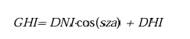
After preprocessing the data, the research applied Fuzzy C-Means clustering to several variables including Direct Irradiance (DNI), Diffuse Irradiance (DHI), Global Horizontal Irradiance (GHI), Temperature , Electricity and some computed variables such as Direct-Diffuse Ratio (DDR), Coefficient of Variation of Irradiance (CV_DNI) and Coefficient of Variation of GHI (CV_GHI). The Fuzzy C-Means clustering method was used to identify the patterns in solar radiation data. Fuzzy C-Means algorithm was selected because it allows each datapoints degrees of membership in clusters. The quality of the clusters evaluated by using Partition Coefficient (PC) and Xie-Beni Index (XB) to ensure reliable clustering results.In addition a statistical independent samples t – test was conducted to examine the differences in Global Horizontal Irradiance (GHI) between identified clusters.

3.2 Population, sample and Sampling technique
The population of this study is based on satellite based solar radiation and environmental data recorded for Sri Lanka, and the sample used is the solar radiation and environmental data from kirulapone region in Sri Lanka for year 2019. The variables include Direct Irradiance (DNI), Diffuse Irradiance (DHI), Temperature, Electricity and the calculated Global Horizontal Irradiance (GHI). A purposive sampling technique was used as the sampling technique so the dataset specifically chosen its accuracy, completeness and relevance to Sri Lanka’s tropical climate.

3.3 Type of Data to be collected and data sources
This study uses satellite-based data from NASA MERRA 2 for the Kirulapone region of Sri Lanka. This dataset covers hourly data for entire for year 2019. The variables are Direct Normal Irradiance (DNI) , Diffuse Horizontal Irradiance (DHI), Temperature and Electricity, Target variable Global Horizontal Irradiance (GHI) will be calculated using Direct Normal irradiance and Diffuse Horizontal Irradiance in cooperating with Solar Zenith Angle (SZA) which is derived from time and geographical position. In addition derived indicators was calculated to support pattern recognition, Direct-Diffuse Ratio (DDR) for Sky conditions and Coefficient of Variation of Irradiance (CV_DNI) for Irradiance Stability and Coefficient of Variation of GHI (CV_GHI) for GHI Variability.

3.4 Data collection tools and plan
This study uses the NASA MERRA-2 reanalysis database which offers credible satellite records on solar and meteorological data. 2019 hourly data of the Kirulapone region in Sri Lanka is downloaded with its Direct Normal Irradiance (DNI), Diffuse Horizontal Irradiance (DHI), temperature and Electricity. The Global Horizontal Irradiance (GHI) calculated using Direct Irradiance (DNI), Diffuse Irradiance (DHI) and whereas the Solar Zenith Angle (SZA) is calculated using geographic coordinates and timestamps. In addition derived indicators was calculated to support pattern recognition, Direct-Diffuse Ratio (DDR) for Sky conditions using Direct Irradiance (D and Coefficient of Variation of Irradiance (CV_DNI) for Irradiance Stability and also Coefficient of Variation of GHI (CV_GHI) for GHI Variability.

3.5 Conceptual framework
Clustering Pattern recogniction
(Applying Fuzzy C_means clustering)
Solar and Environmental Variables
(DHI,DNI,GHI,Temperature, Electricity, DDR, CV_DNI, CV_GHI)

3.6 Hypothesis
Null Hypothesis (H₀)
There is no significant difference between in Global Horizontal Irradiance (GHI) among the identified fuzzy clusters
Alternative Hypothesis (H₁)
There is significant difference between in Global Horizontal Irradiance (GHI) among the identified fuzzy clusters

3.7 Operationalization Table
Variables | Definition | Indicators | Measures | Reference
DNI (Direct Normal Irradiance) | Direct solar radiation per unit area | DNI values from NASA MERRA 2 Dataset | W/m² (hourly) | NASA MERRA - 2
DHI (Diffuse Horizontal Irradiance) | Scattered solar radiation received on a horizontal surface | DHI values from NASA MERRA 2 Dataset | W/m² (hourly) | NASA MERRA - 2
SZA (Solar Zenith Angle) | Angle between sun’s rays and vertical line | Computed from time & Location | Degrees (°) | Computed
Temperature | Air temperature | NASA MERRA-2 dataset | °C | NASA MERRA – 2 datasets
Electricity | Power Output | NASA MERRA-2 dataset | kWh | NASA MERRA – 2 datasets
Global Horizontal Irradiance (GHI) | Total solar radiation on a horizontal surface | Calculated using DNI, DHI and SZA | W/m² | Calculated
Direct – Diffuse Ratio | Sky Clarity measure | Calculated using DNI and DHI |  | Derived Indicator
Coefficient of Variation in Irradiance (CV_DNI) | Variation in Irradiance | Calculated using Std of DNI and Mean of DNI |  | Derived Indicator
Coefficient of Variation in GHI (CV_GHI) | Variation in GHI | Calculated using std of GHI and mean of GHI |  | Derived Indicator

3.8 Methods of data analysis
The data were analyzed using python to perform Fuzzy C-Menas Clustering and Identify solar radiation patterns.
Data Cleaning & Preprocessing:
First Handel the missing values and converted the hourly data to daily averages then calculated the Global Horizontal Irradiance using Direct Irradiance and Diffuse Irradiance and Solar Zenith Angle. The Solar Zenith Angle (SZA) is calculated using geographic coordinates and timestamps.
In addition, derived indicators was calculated to support pattern recognition, Direct-Diffuse Ratio (DDR) for Sky conditions using Direct Irradiance and Diffuse Irradiance and Coefficient of Variation of Irradiance (CV_DNI) for Irradiance Stability using Standard Deviation and Mean of DNI and also Coefficient of Variation of GHI (CV_GHI) for GHI Variability using Standard Deviation and Mean of GHI.

DDR = Direct Irradiance + Diffuse Irradiance
CV_DNI = Direct Irradiance Standard Deviation / Direct Irradiance Mean
CV_GHI = Global Horizontal Irradiance Standard Deviation / Global Horizontal Irradiance Mean
For each variable mean values were calculated to represent the average solar and environmental conditions for each day,
Scaling:
min-max scaling part was applied to normalize all variables between 0 and 1.
Fuzzy C-Mean Clustering:
Clustering techniques analyze data to group similar samples into clusters, there are two main types of clustering one is hard clustering, where each sample belongs to only one cluster and other one is soft clustering like fuzzy clustering where each sample belongs to multiple clusters with different degrees of membership. the commonly used fuzzy clustering method is the Fuzzy C-Means clustering method. (Hamza Ali-Ou-Salah, Benyounes Oukarfi and Tlemcani Mouhaydine, 2021)
The study Applied Fuzzy C-Means clustering to scaled data, input features included the mean values of Direct Irradiance, Diffuse Irradiance, Global Horizontal Irradiance, temperature, electricity, Direct – Diffuse ratio, and Coefficient of Variation in Irradiance and Coefficient of Variation in GHI. The number of clusters was determined to ensure meaningful pattern separation. Partition Coefficient (PC) and Xie Beni Index (XB) used to find the optimal clusters.
Cluster Validation:
Cluster quality validates using Partition Coefficient (PC) and Xie Beni Index (XB) to measure clustering accuracy and compactness and separation of clusters.
Cluster Evaluation:
Used histograms and membership graphs to show cluster separation and fuzzy membership distribution. Then conducted a statistical test (t-test) to check if there were significant differences in GHI values among clusters.
Data Cleaning & Preprocessing

Scaling

Fuzzy C-Means Clustering

Cluster Validation

Cluster Evaluation
Chapter 4: Data Analysis
4.1 Data Analysis
This study use NASA MERRA-2 satellite data for solar radiation in kirulapone region in Sri Lanka. The variables are Direct Irradiance , Diffuse Irradiance, Temperature, Electricity and the Global Horizontal Irradiance using Direct Irradiance and Diffuse Irradiance and Solar Zenith Angle. The Solar Zenith Angle (SZA) is calculated using geographic coordinates and timestamps. Derived indicators was calculated to support pattern recognition, Direct-Diffuse Ratio (DDR) for Sky conditions using Direct Irradiance and Diffuse Irradiance and Coefficient of Variation of Irradiance (CV_DNI) for Irradiance Stability using Standard Deviation and Mean of DNI and also Coefficient of Variation of GHI (CV_GHI) for GHI Variability using Standard Deviation and Mean of GHI.

Preprocessing
The data was cleaned and quality filtered, then the data was aggregated into daily level features , mean values of the DNI,DHI,GHI, temperature , electricity, DDR, CV_DNI, CV_DHI calculated to represent the average condition for each day
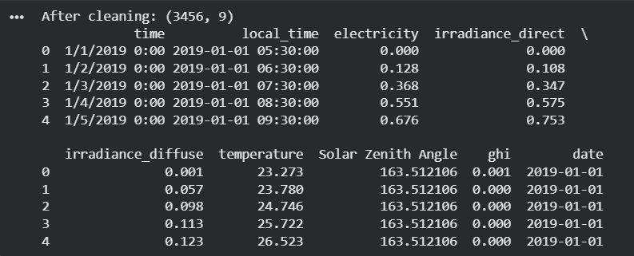
Figure 01
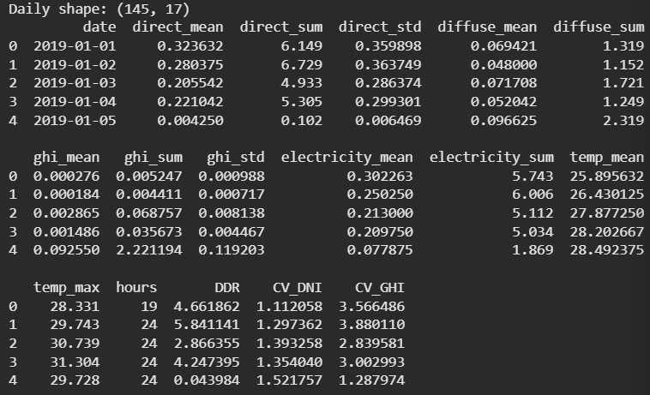
Figure 02
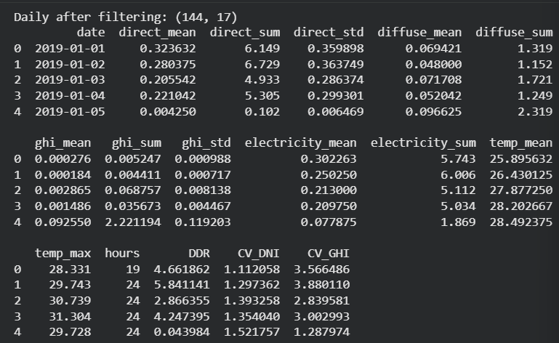

Figure 03

Scaling
min-max scaling part was applied to normalize all variables between 0 and 1 to ensure all variables are in comparable range prior to clustring
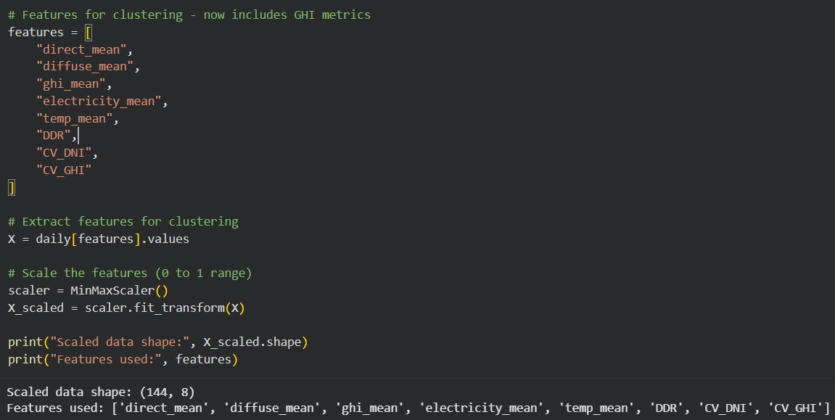
Figure 04

Fuzzy C-Means Clustering and Cluster Validation
To determine the optimal number of clusters for Fuzzy C-Means clustering , The Partition Coefficient (PC) and Xie Beni Index (XB) is used. Considering both validity metrics two clusters have identified as the optimal clusters for the Fuzzy C-Means clustering.

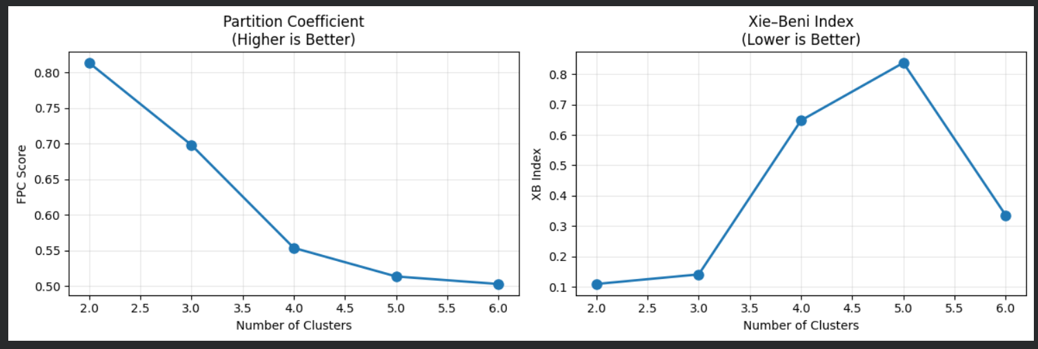
Figure 05
The pc value shows Fuzzy C-Mean clustering was 0.8134. PC measures how clearly datapoints are assigned to the clusters with closer to 1 it indicates better defined clustering. The Fuzzy C-Means cluster distribution shows from 144 days, 84 days were assigned to Cluster 1 and other 60 days are assigned to Cluster 0 based on maximum membership values.
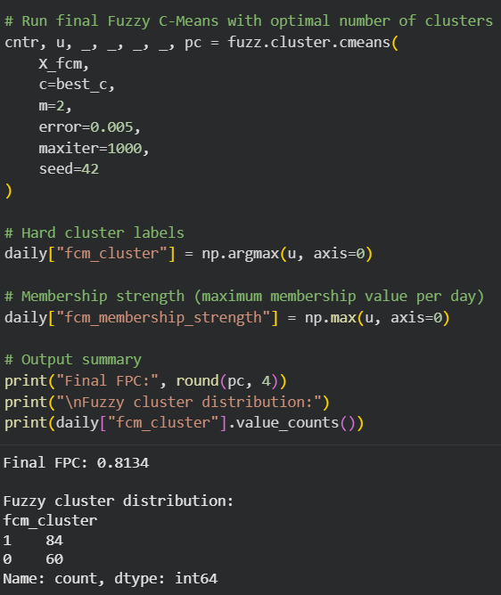
Figure 06

This shows the average feature values for cluster 0 and cluster 1. It describes a typical profile of datapoints in each cluster. All values are normalized to 0-1.
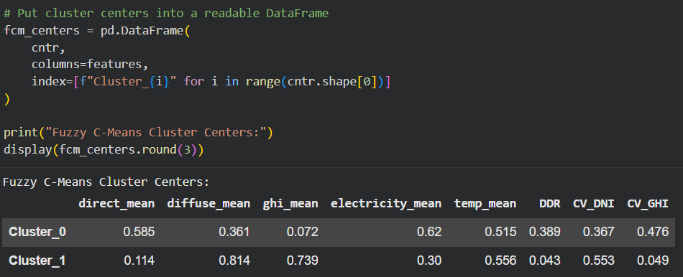

Figure 07
The fuzzy membership matrix shows the degree of membership of each data sample in each cluster, the higher value means the sample belongs to more strongly that cluster.
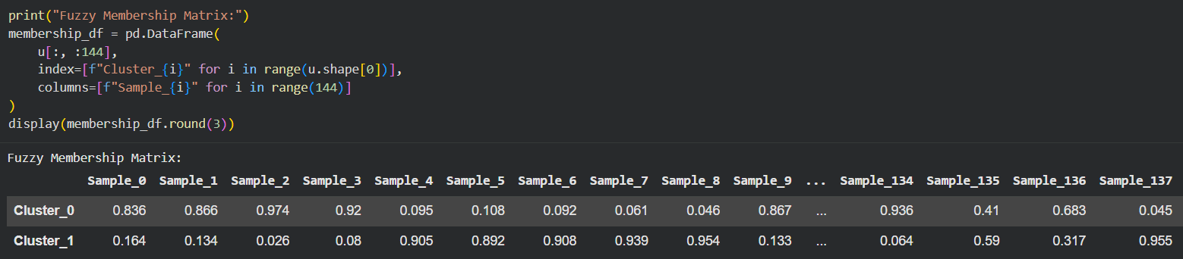
Figure 07

Fuzzy C-Means Evaluation
Distribution of Fuzzy Membership Strength histogram shows how strongly each day belongs to the relevant cluster, higher values mean clear cluster assignments and lower values means the overlap between the cluster 1 and cluster 0

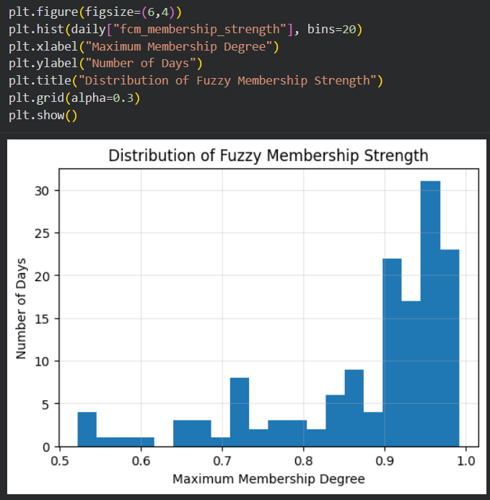
Figure 08

The dataset was clustered into two clusters based on solar and environmental data, the histograms of variables shows the operational difference between the clusters

Solar Radiation Characteristics
The cluster 0 shows higher direct_mean values , moderate diffuse_ mean and very low ghi_mean which shows dominance of direct solar radiation, and cluster 1 shows lower direct_mean value but high diffuse_mean and ghi_mean values. Suggesting diffuse dominated conditions.
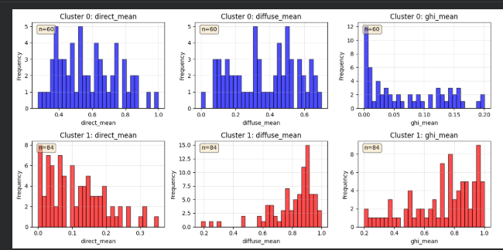
Figure 09

Electricity and Temperature
The electricity_mean is higher in cluster 0 than cluster 1 but it have lower temperature which indicate high power outpu but more fluctuation conditions and cluster 1 indicates lower electricity output and higher temperature which means it have lower power output and more stable temperature.
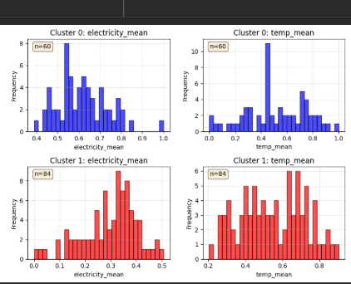
Figure 10

Variability and Sky Condition Metrics
Cluster 0 has higher DDR and CV_GHI indicates greater day to day variability and clear ski conditions. But cluster 1 displays very low DDR and CV_GHI, reflecting stable but diffuse irradiance, CV_DNI is higher in cluster 1 than cluster 0 showing direct radiation is unreliable under cloudy conditions.
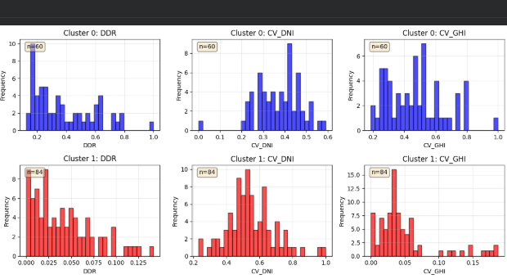
Figure 11

T test was used to check the difference in GHI values between cluster 1 and cluster 0 , cluster 1 have GHI (0,0783) than cluster 0 (0.0075). The t-statistic very large and p-value is essentially zero , which shows that there is difference in GHI values between cluster 1 and Cluster 0

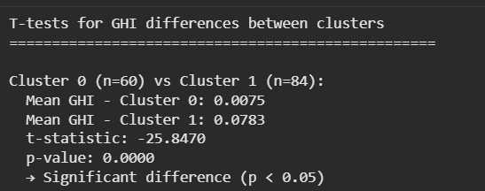
Figure 12

The boxplot shows the distribution of mean GHI value for the cluster 1 and cluster 0. Cluster 0 have low GHI value that closer to zero but cluster 1 has higher GHI value with wider spread, the boxplot shows the significant difference between cluster 0 and Cluster 1.

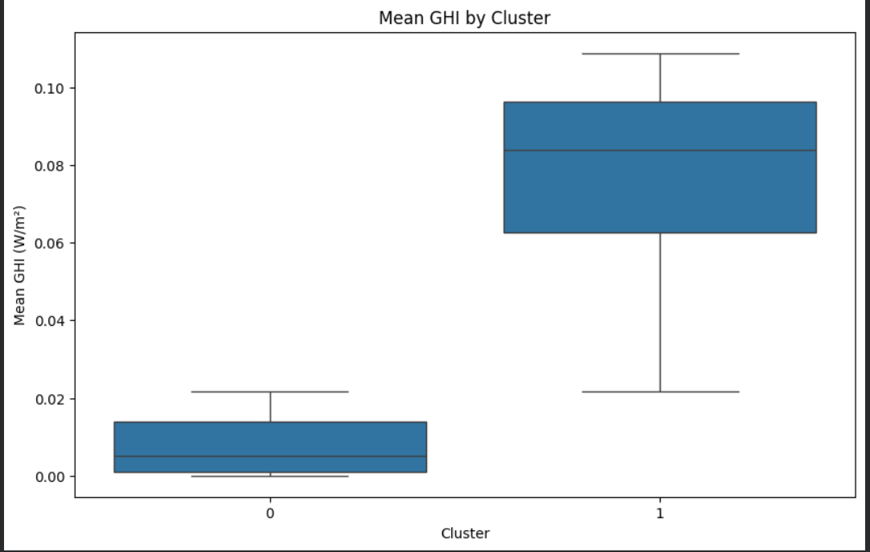
Figure 13

4.2 Findings and Interpretation
The findings of the study is based on the results that obtained from the Fuzzy C-Means clustering and statistical validation. The fuzzy cluster results are indicate two clusters, the validity metrics are Partition Coefficients and Xie Beni index, based on maximum membership values 84 days are assigned to the cluster 1 and 60 days assigned to cluster 0. The cluster centers shows the difference between the two clusters.

The histogram shows the distribution of key variables for cluster 1 and cluster 0, the plot helps to identify clusters different patterns.


Figure 14

Figure 15


Figure 16
Direct Irradiance Mean (direct_mean)
Cluster 0 shows moderate to high direct irradiance while cluster 1 shows lower direct irradiance values which indicates in that cluster 0 have days with stronger sunlight while cluster 1 indicate days with weaker sunlight.

Diffuse Irradiance Mean (diffuse_mean)
Cluster 1 shows higher diffuse irradiance while cluster 0 shows lower diffuse irradiance which represents that cluster 1 there is increased scattering in solar radiation and cluster 0 indicate clearer sky conditions with less scattering.

Global Horizontal Irradiance (ghi_mean)
So the cluster 1 clearly shows higher GHI value with most days concentrated at upper end of the distribution while Cluster 0 shows lower GHI value indicating reduced overall solar radiation reaching the surface.

Electricity
Cluster 0 shows higher electricity , concistent with higher direct irradiance and clear conditions. But cluster 1 shows lower electricity, showing reduced effectiveness of solar energy production under diffuse- dominated conditions.

Temperature
Cluster 1 clearly shows higher temperatures while cluster 0 shows moderate temperatures level

Direct – Diffuse Ratio (DDR)
Cluster 0 shows higher DDR values indicating dominance of direct radiation while cluster 1 has very low DDR which indicates dominance of diffuse irradiance.

Variability Indices (CV_DNI , CV_GHI)
Cluster 0 shows higher variability indicating larger fluctuations in irradiance during the day while cluster 1 shows lower variability suggesting more stable but diffuse dominated conditions.

Overall the two cluster represts physically meaningful sola radiation patterns
Cluster 0 assigned to days with higher direct irradiance , higher electricity output , higher DDr and greater variability while Cluster 1 assigned to days with higher diffuse irradiance, higher GHI, lower DDR and Lower variability. Which simply means that cluster 0 have Clear direct sun days while and better power output while cluster 1 have cloudier, spread out sunlight days and lower power output.

T – test

Figure 17
T test was used to check the difference in GHI values between cluster 1 and cluster 0 , cluster 1 have GHI (0,0783) than cluster 0 (0.0075). The t-statistic very large and p-value is essentially zero , which shows that there is difference in GHI values between cluster 1 and Cluster 0 , which indicate that we reject the Null Hypothesis and Accept the Alternative Hypothesis.


Figure 18
The boxplot shows the distribution of mean GHI value for the cluster 1 and cluster 0. Cluster 0 have low GHI value that closer to zero but cluster 1 has higher GHI value with wider spread, the boxplot shows the significant difference between cluster 0 and Cluster 1.

Chapter 5: Discussion and Recommendations

5.1 Discussion
This paper used Fuzzy C-Means (FCM) clustering to identify patterns of solar radiation on various days with the help of irradiance, environmental, and electricity-related variables. The findings revealed that the data is capable of being well clustered into two separate categories, which constitute two different patterns of solar radiations.
One cluster was noted to be more direct irradiance, greater Direct-Diffuse Ratio (DDR), and greater power generation, which were the clear days with greater direct sunlight intensity. The other cluster was more diffuse irradiance and Global Horizontal Irradiance (GHI), and indicates a cloudier day with greater scattered sunlight. These results are in agreement with theoretical knowledge of the solar radiation behavior in various atmospheric conditions.
Validation measures such as the large Partition Coefficient (PC) and low Xie, Beni Index supported the quality of the clustering. Moreover, the independent samples t-test supported the fact that there is statistically significant difference in the mean GHI in the two clusters, which means that the observed patterns are not random.
In general, the findings indicate that Fuzzy C-Means clustering can be used as an effective method to identify the solar radiation patterns and obtain the relationship between the patterns and electricity production.

5.2 Recommendations
According to the results of this research, the following recommendations are possible:

Solar energy planning application:
The patterns of solar radiations identified can be utilised in solar energy performance analysis and planning. It is possible to analyze clear-sky and diffuse-dominated days separately so as to gain a better insight into the variability of solar power.

Communication with decision-making tools:
The clustering model can be incorporated in the solar energy monitoring systems to classify days based on radiation properties to assist in operational decision-making and performance analysis.

Use of additional variables:
To develop pattern recognition and gain more insight into atmospheric effects, future research can incorporate more meteorological factors like humidity or wind velocity or cloud cover.

Scaled-up to larger data sets:
It would enhance the strength and extrapolation of the findings by implementing the same methodology to several years of data or another geographical area.

5.3 Conclusions
The study was able to use Fuzzy C-Means (FCM) clustering to identify the pattern of solar radiation on various days through the processed irradiance, environmental, and electricity related data. Two meaningful solar radiation patterns were identified and found to be significant through analysis and confirmed with fuzzy cluster validity indices and statistical tests.
The research questions were also answered by showing that Fuzzy C-Means clustering is a useful solution when it comes to recognizing the patterns of solar radiation. High Partition Coefficient and low Xie Bini Index confirmed the good quality of clustering and the independent samples t-test statistically demonstrated the difference between Global Horizontal Irradiance (GHI) between the identified clusters. These findings prove that the clusters are actually different solar radiation conditions and not arbitrary clusters.
The results indicate that fuzzy clustering methods are useful in the analysis of complex and variable solar radiation data. The research offers details on the relationship between the nature of solar radiation and the production of electricity by determining the presence of distinct and less distinct radiation patterns.
Future studies can expand on this study by incorporating more meteorological variables, longer time scales, extending the method to alternative geographical scales and using the outcome of the clustering with forecasting or decision-support models to use solar energy.

List of Reference:
Lathief, M.F., Soesanti, I. and Permanasari, A.E. (2019). Combination of Fuzzy C-Means, Xie-Beni Index, and Backpropagation Neural Network for Better Forecasting Result. Proceedings of the International Conference on Creative Economics, Tourism and Information Management, [online] pp.72–77. doi:https://doi.org/10.5220/0009858200720077.
Hamza Ali-Ou-Salah, Benyounes Oukarfi and Tlemcani Mouhaydine (2021). Short-term solar radiation forecasting using a new seasonal clustering technique and artificial neural network. International Journal of Green Energy, 19(4), pp.424–434. doi:https://doi.org/10.1080/15435075.2021.1946819.
Lai, C.S., Jia, Y., McCulloch, M.D. and Xu, Z. (2017). Daily Clearness Index Profiles Cluster Analysis for Photovoltaic System. IEEE Transactions on Industrial Informatics, 13(5), pp.2322–2332. doi:https://doi.org/10.1109/tii.2017.2683519.
‌Alsalman, M., Marwa Alraeesi and Ayman Alzaatreh (2025). Multivariate analysis of energy and solar performance across Dubai: insights from MANOVA and cluster analysis. Scientific Reports, [online] 15(1). doi:https://doi.org/10.1038/s41598-025-09730-4.
Yusak Tanoto, Gregorius Satia Budhi and Sean Frederick Mingardi (2024). Clustering-based assessment of solar irradiation and temperature attributes for PV power generation site selection: A case of Indonesia’s Java-Bali region. International Journal of Renewable Energy Development, 13(2), pp.351–361. doi:https://doi.org/10.61435/ijred.2024.59998.
Yang, M.-S. and Nataliani, Y. (2017). Robust-learning fuzzy c-means clustering algorithm with unknown number of clusters. Pattern Recognition, 71, pp.45–59. doi:https://doi.org/10.1016/j.patcog.2017.05.017.
Kim, D.-W. and Lee, K.H. (2024). A new validity measure for fuzzy c-means clustering. [online] doi:https://doi.org/10.48550/arXiv.2407.06774.
Mahela, O.P. and Shaik, A.G. (2017). Power quality recognition in distribution system with solar energy penetration using S -transform and Fuzzy C-means clustering. Renewable Energy, 106, pp.37–51. doi:https://doi.org/10.1016/j.renene.2016.12.098.
‌Zhang, Z., Wang, C., Peng, X., Qin, H., Lv, H., Fu, J. and Wang, H. (2021). Solar Radiation Intensity Probabilistic Forecasting Based on K-Means Time Series Clustering and Gaussian Process Regression. IEEE Access, [online] 9, pp.89079–89092. doi:https://doi.org/10.1109/ACCESS.2021.3077475.
‌Garcia-Gutierrez, L., Voyant, C., Notton, G. and Almorox, J. (2022). Evaluation and Comparison of Spatial Clustering for Solar Irradiance Time Series. Applied Sciences, 12(17), p.8529. doi:https://doi.org/10.3390/app12178529.
‌Anon, (n.d.). Enhanced joint hybrid deep neural network explainable artificial intelligence model for 1-hr ahead solar ultraviolet index prediction.
Anon, (n.d.). Comparative analysis of deep learning techniques for global horizontal irradiance forecasting in US cities.
Anon, (n.d.). Deep learning algorithms for very short term solar irradiance forecasting: A survey.
Anon, (n.d.). Improving day-ahead Solar Irradiance Time Series Forecasting by Leveraging Spatio-Temporal Context.
Anon, (n.d.). Solar Radiation Analysis & Prediction Using Machine Learning Algorithms.
Anon, (n.d.). Multi-step solar ultraviolet index prediction: integrating convolutional neural networks with long short-term memory for a representative case study in Queensland, Australia.
Anon, (n.d.). Sequence to sequence deep learning models for solar irradiation forecasting.
Anon, (n.d.). improved satellite-based intra-day solar forecasting with a deep learning model chain" – S. Chen et al., 2024 Introduces a novel.
Anon, (n.d.). GHI CORRELATIONS WITH DHI AND DNI AND THE EFFECTS OF CLOUDINESS ON ONE-MINUTE DATA .
Anon, (n.d.). A deep learning model for multi-modal spatio-temporal irradiance forecasting" – S. Shan et al., 2024.
Moreno-Tejera, S., Larrañeta, M., Isidoro Lillo-Bravo and Silva-Pérez, M. (2020). A normalized variability index of daily solar radiation. AIP Conference Proceedings, [online] 2303(1), p.180005. doi:https://doi.org/10.1063/5.0028919.
‌ Voyant, C., Julien, A., Despotovic, M., Notton, G., Garcia-Gutierrez, L.A., Nicolosi, C.F., Blanc, P. and Bright, J. (2025). Stochastic Coefficient of Variation: Assessing the Variability and Forecastability of Solar Irradiance. arXiv.org. [online] doi:https://doi.org/10.1016/j.renene.2025.123913.
‌ Lantz, K., P. Disterhoft, P. Kiedron, Slusser, J. and Peck, F. (2008). Direct-to-diffuse UV solar irradiance ratio for a UV rotating shadowband spectroradiometer (UV-RSS) and a UV multi-filter rotating shadowband radiometer (UV-MFRSR). [online] Available at: https://www.researchgate.net/publication/242302166_Direct-to-diffuse_UV_solar_irradiance_ratio_for_a_UV_rotating_shadowband_spectroradiometer_UV-RSS_and_a_UV_multi-filter_rotating_shadowband_radiometer_UV-MFRSR.
‌ Garcia-Gutierrez, L., Voyant, C., Notton, G. and Almorox, J. (2022). Evaluation and Comparison of Spatial Clustering for Solar Irradiance Time Series. Applied Sciences, 12(17), p.8529. doi:https://doi.org/10.3390/app12178529.
‌

‌

